Worksheet Numbers and colours Name:__________________

20
1.
2.
3.
4.
5.
6.
7.
8.
!

10
12
11

dvere
4

9
16

colour five green apples
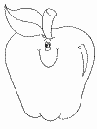
colour twelve blue butterflies
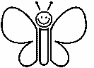
colour eight red flowers
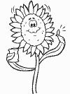
colour thirteen yellow bananas
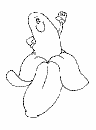
618
eighteenten
10nine
twentysix
97
seven20
15 - _____________
____ - twelve
19 - _____________
____ - eighteen
3 - _____________
______ - four
17 - _____________
____ - two

